
My Target : /45 or ___%  

NAME:__________________
3A/B Geography
Task 8 – Natural Climate Systems
Weighting = 5% Total=45 marks
Working time – 45 minutes Reading time – 5 minutes

Section One: Multiple Choice 25 marks (1 mark each question)

1. Which of the following pressure belts are found between 80 and 90 degrees south?

a) polar low
b) equatorial low
c) polar high
d) sub tropical high

2. All weather systems and surface winds occur in the:

a) stratosphere
b) thermosphere
c) troposphere
d) mesosphere

3. The earth’s atmosphere may be divided into 4 distinct layers from sea level. These layers occur in which of the following orders?

a) troposphere, stratosphere, mesosphere, thermosphere
b) troposphere, mesosphere, stratosphere, thermosphere
c) stratosphere, troposphere, thermosphere, mesosphere
d) mesosphere, troposphere, thermosphere, stratosphere

4. Which of the following factors will not affect the amount of insolation the earth receives?

a) latitude
b) season
c) composition of the atmosphere

d) distribution of daylight hours

e) altitude

5. The global heat budget is described as the:

a) balance between incoming insolation and outgoing thermal radiation
b) gain of heat produced through thermal radiation
c) transfer of heat from the tropics to the poles
d) gain or loss of heat in the atmosphere

6. Which two statements are incorrect?

1. the atmosphere is heated through long wave radiation
2. the atmosphere is heated through short wave radiation
3. the earth is heated through short wave radiation
4. the earth is heated through long wave radiation

a) 1 & 2
b) 3 & 4
c) 1 & 3
d) 2 & 4

7. Insolation stands for:

a) incoming solar radiation
b) incoming sun rays
c) incoming solar reflection
d) incoming solar rays

8. The degree of reflection is referred to as:

a) reflection
b) albino
c) albedo
d) reflectivity

9. Two of the following proposals concerning the Greenhouse Effect are incorrect. Which two are untrue?

Without the Greenhouse Effect the earth would:

i) experience freezing nights
ii) not maintain a relatively constant planetary temperature
iii) result in a greater range between minimum and maximum temperatures
iv) retain more long-wave heat energy
v) experience a smaller range of maximum and minimum temperatures

a) i & ii
b) ii & iv
c) iv & v
d) iii & v

10. In the Greenhouse Effect, the earth’s atmosphere

a) permits all radiated heat to escape as short wave radiation
b) allows only part of the radiated heat to escape as long wave radiation
c) allows all radiated heat to escape as long wave radiation
d) permits only a portion of radiated heat to escape as short wave
radiation

11. The Greenhouse diagram below illustrates:

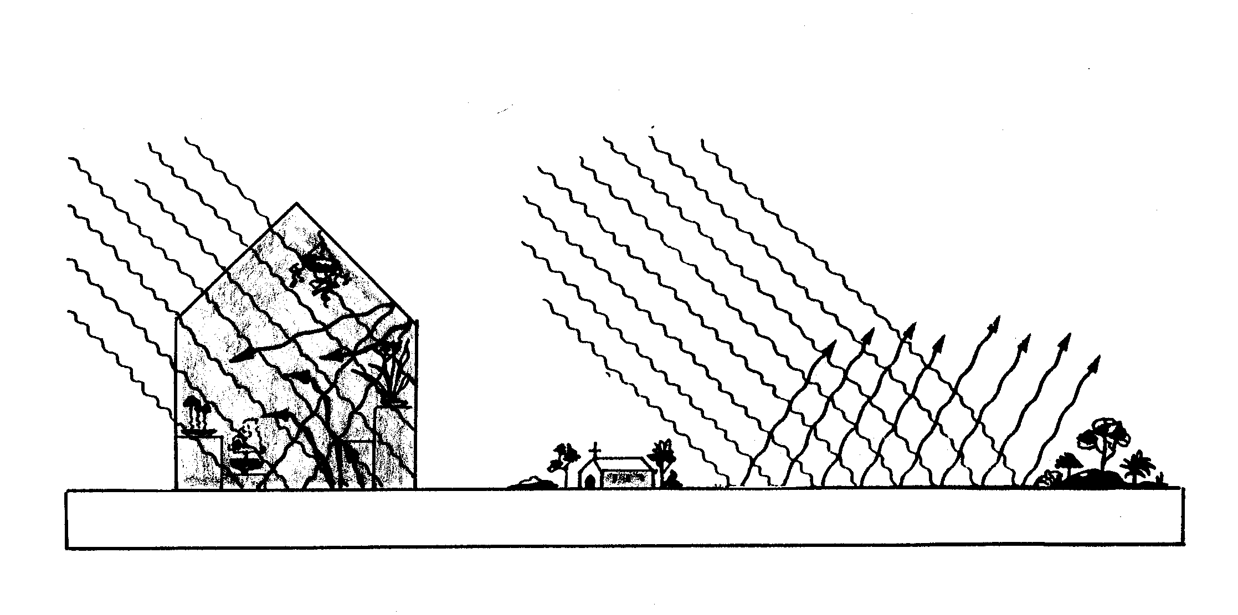
Atmosphere
Greenhouse

a) incoming solar radiation warms up both the glasshouse and atmosphere

b) insolation becomes trapped inside the glasshouse, causing it to warm up

c) shortwave radiation warms the greenhouse

d) longwave heat energy can not escape easily through the greenhouse, thus
the greenhouse stays warm

e) the atmosphere and greenhouse operate similarly as long wave radiation
passes slowly out of the greenhouse and atmosphere, causing it to remain
warm

12. A high pressure system is often associated with which weather conditions?
a) stable, fine and clear
b) unstable, clear and frosty
c) unstable and cloudy
d) rainy and cloudy

13. Which line on a map joins places of equal atmospheric pressure?

a) isobar
b) isotherm
c) isohyet
d) isohypse

14. Which of the following does not correctly define climate?
Climate is:
a) general weather conditions
b) the average of weather
c) the long term seasonal pattern
d) conditions of the atmosphere at a particular time
- the long term conditions of the atmosphere

15. All but two of the following are elements of weather. Which two do not belong?

rainfall, wind, latitude, temperature, air pressure, humidity, cloud and ocean currents.

a) ocean currents & latitude
b) ocean currents & cloud
c) rainfall and temperature
d) air pressure and humidity

16. Combustion, respiration and photosynthesis are key elements of which natural system?

- the hydrological cycle
- heat budget
- atmospheric circulation
- the carbon cycle

17. Which of the following best describes why the greenhouse effect occurs within the earth’s atmosphere?

- An increase in pollution in the lower atmosphere as a result of human activity traps ultra violet radiation.
- A decrease in the albedo rate occurs as a result of a reduction in the polar ice caps.
- The development of holes in the ozone layer in both polar regions allows an increase in solar radiation.
- Gases in the lower atmosphere prevent the escape of terrestrial radiation.

18. Provide one example of a human modification to the hydrological cycle.
(1 mark)

______________________________________________________________

______________________________________________________________

19. Identify the THREE main types of RAINFALL. (1 ½ marks)

- ____________________________________

- ____________________________________

- ____________________________________

20. List THREE factors affecting climate. (1 ½ marks)

- ____________________________________

- ____________________________________

- ____________________________________

21a. IDENTIFY and STATE what the letters A-H are representing on Figure One – The Hydrological Cycle. (4 marks)

A - _____________________________ B - _________________________

C- _____________________________ D - __________________________

E- _____________________________ F- ___________________________

G- _____________________________ H -___________________________

21b. With reference to the diagram above - Figure One – The Hydrological Cycle , define and describe the operation of the hydrological cycle. (8 marks)

______________________________________________________________

______________________________________________________________

______________________________________________________________

______________________________________________________________

______________________________________________________________

______________________________________________________________

______________________________________________________________

______________________________________________________________

______________________________________________________________

______________________________________________________________

______________________________________________________________

______________________________________________________________

______________________________________________________________

______________________________________________________________

______________________________________________________________

______________________________________________________________

______________________________________________________________

______________________________________________________________

______________________________________________________________

______________________________________________________________

______________________________________________________________

______________________________________________________________

______________________________________________________________

______________________________________________________________

______________________________________________________________

______________________________________________________________

______________________________________________________________

______________________________________________________________

______________________________________________________________

______________________________________________________________

______________________________________________________________

______________________________________________________________

______________________________________________________________

______________________________________________________________

______________________________________________________________

______________________________________________________________

______________________________________________________________

______________________________________________________________

22. With the aid of a diagram, describe the operation of the Heat Budget. (6 marks)

______________________________________________________________

______________________________________________________________

______________________________________________________________

______________________________________________________________

______________________________________________________________

______________________________________________________________

______________________________________________________________

______________________________________________________________

______________________________________________________________

______________________________________________________________

______________________________________________________________

______________________________________________________________

______________________________________________________________

______________________________________________________________

______________________________________________________________

______________________________________________________________

______________________________________________________________

23. Using specific examples differentiate between the terms weather and climate. (5 marks)

______________________________________________________________

______________________________________________________________

______________________________________________________________

______________________________________________________________

______________________________________________________________

______________________________________________________________

______________________________________________________________

______________________________________________________________

______________________________________________________________

______________________________________________________________

______________________________________________________________

______________________________________________________________

______________________________________________________________

______________________________________________________________

24. Outline the key elements of the carbon cycle. (3 marks)

______________________________________________________________

______________________________________________________________

______________________________________________________________

______________________________________________________________

______________________________________________________________

______________________________________________________________

______________________________________________________________

______________________________________________________________

______________________________________________________________

______________________________________________________________

25. Use the key to label the carbon cycle. Place the letter in the corresponding label box. (6 marks)

